**Conclusion of Excel challenge:**

1, On the first pivot table we can see the distribution of outcome on parents’ category. Category theatre shows the maximum number of outcomes, as well as maximum successful outcomes. Film & video and music are second and third respectively.

2. The play subcategory alone was skyrocketing on the chart. Whereas around 39% events failed on this category.

3. On chart 3 we find June and July months were most prolific months. Whereas there is no trend or relationship observed between outcome categories.

**Limitaion:**

No analysis has been done with average donation’s relationship with other categories. But it’s one of the biggest key factor to success.

**Additional Graphs**

We can change the chart type of pivot table 1 to 100% stacked column. And here we can see journalism poses 100% success. And the second largest success 65% cames from the technology category,

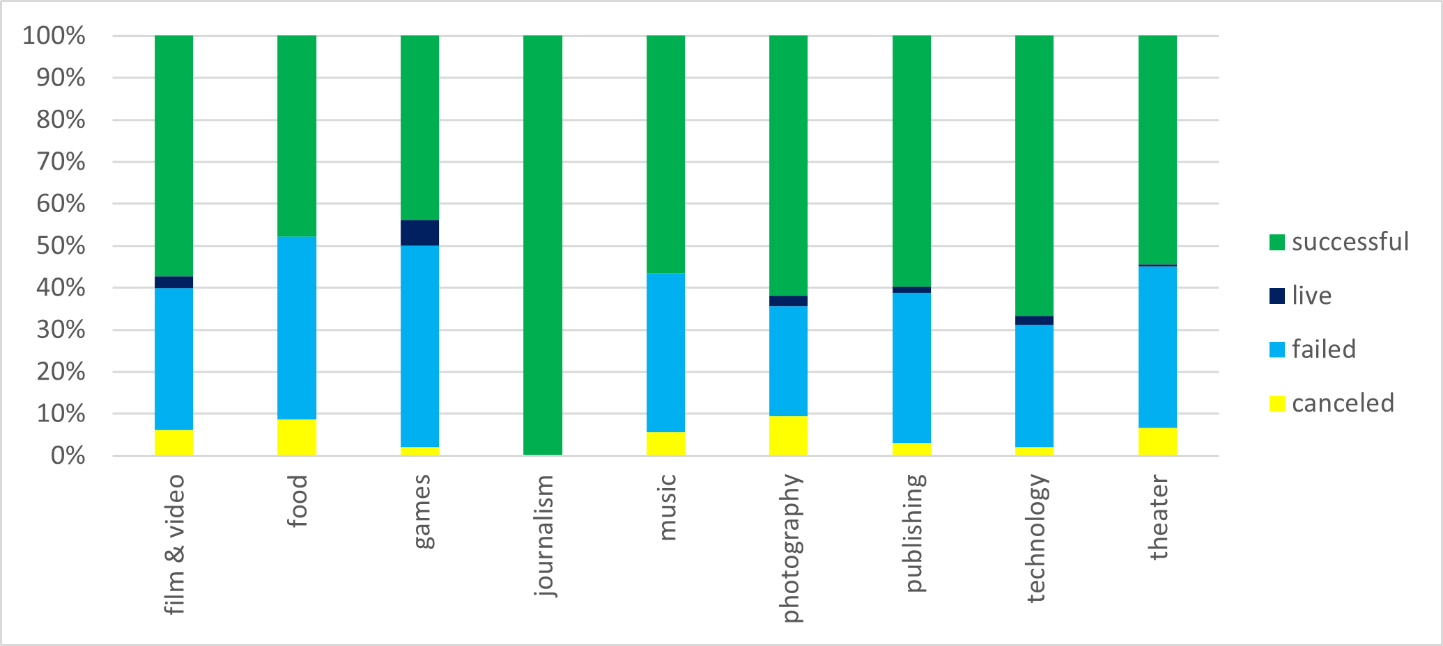

If we change the chart type to 100% stacked column we will see the web, rock and audio subcategories poses higher success rate.

